Meta Description:
Facebook Marketing is an advertising way to promote products, services, and brands on the Facebook Platform. Read and learn how to do it effectively in 2025.
https://drive.google.com/drive/folders/1Xg8b_-U8fRAJzCIMnBLyBPFD6IzyvYpi

What is Facebook Marketing & How to Do it Effectively in 2025
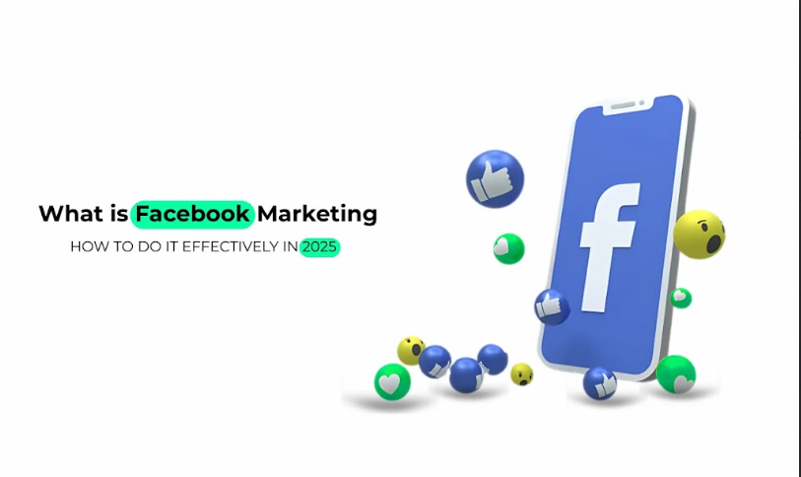
As time goes on, there has been increasing pressure put on organizations under tremendous pressure to find the best ways of reaching consumers.
When it comes to the promotion of products & services, there is no better option than Facebook Marketing.
If you want to prepare for the future and plan appropriately for the year 2025, you must comprehend the most effective ways of leveraging Facebook Marketing.
In this blog post, we answer the many questions, which are What Facebook Marketing Is, Why It Is Indispensable for Businesses, and the guidelines on How to Manage It in the Future.

1. What Is Facebook Marketing?
Facebook Marketing is the process of e-marketing through the social network known as Facebook.
Facebook Marketplace is used by businesses with the aim of reaching a large segment of the audience, creating brand identity, and generating sales.
This plan follows various tools and stances to reach and influence the users in order to meet business objectives.

How Businesses Use Facebook For Promotion?
Brands use Facebook as a marketing tool to advertise their products and services, make announcements, and communicate with potential customers.
This is an effective tool that can be used to share a company’s story in the most informal and friendly manner.

Key Components of Facebook Marketing:
Here are some key components of Facebook Marketing that help you understand its working model:
- Ads: The use of adverts on Facebook via the payment of some amount to post them is one of the major strategies. They enable the targeting of certain groups of people as well as the assessment of campaign results.
- Organic Post: The sharing of content without pay reaches a less targeted audience. This helps in creating a large community in turn engages the followers.
- Engagement: Develop direct contact with the audience through Liking, commenting, and sharing.
- Analytics: It offers a means of analyzing the marketing effectiveness of a particular campaign so that a business can change its strategy.

2. Why Should You Use Facebook Marketing?
The benefits of Facebook Marketing cannot be refuted, especially when the global population expects the world to be marketers and selling to it through social media by 2025. Here are five key reasons to understand the significance of Facebook Marketing:
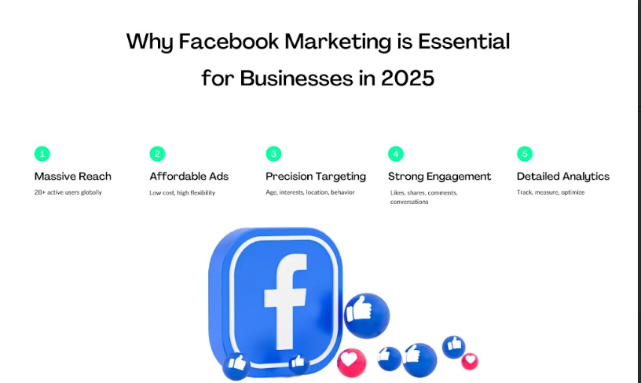

2.1 Massive User Base & Reach
Facebook is the biggest social networking site in the world, with figures in the range of billions of active users.
This large population base implies that brands can easily target a large segment of the population and regions around the globe.
And, by 2025, the proportion of Facebook users must remain the same, if not increase. This provides more chances for businesses to get closer to the consumers.

2.2 Cost-Effective Advertising
Another benefit of using Facebook Marketing is cost efficiency. It is an inexpensive method that does not require a lot of money to implement.
Unlike other channels of advertisements, Facebook enables businesses to put up ads on the business’s Facebook pages at a considerably cheaper price.
It is very helpful for companies, especially the small to medium-sized ones, because they have limited marketing budgets.

2.3 Advanced Targeting Options
From the Facebook advantages list, the advanced targeting options that this platform offers are the most important.
Facebook has powerful features that enable businesses to target virtually any audience through their demographic factors, activities, and interests.
This precision targeting is achieved to make sure that marketing is focused on the right segment that would have an interest in the products or services being marketed.

2.4 High Engagement Potential
The social interaction that is synonymous with the use of Facebook makes it highly interactive and ideal for the purpose.
People can continue using buttons such as like, comment, share, etc, to get closer to the content and provide business organizations the chance to converse with their audience.

2.5 Measurable Results & Analytics
An important advantage of leveraging Facebook Marketing is to assess the results.
Facebook has quite powerful analytical tools that allow monitoring ads and posts.
It is easy to monitor the number of impressions and people’s interaction with content, and this enables businesses to get good results ahead.

3. Types of Facebook Posts to Use in Your Strategy
Let’s have a look at different types of Facebook Marketing that any brand can utilize in their strategies:
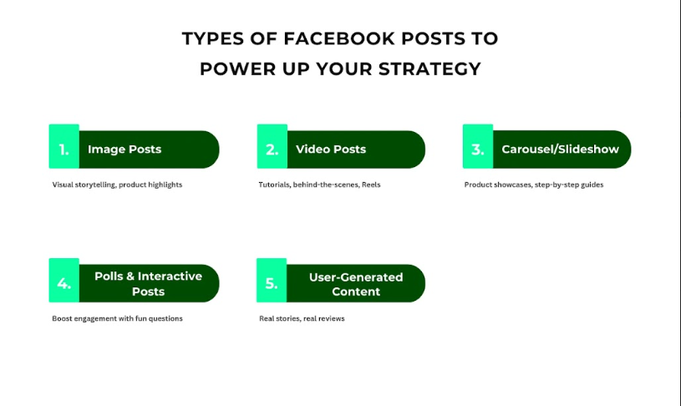

Image Posts:
Photos, in particular, are very popular in people’s sharing activity on Facebook and cannot be dismissed in any modern promotion tactics.
They are perfect tools for grabbing the viewers’ attention and telling your brand story in a rather theatrical manner.
You can use high-quality images to advertise products, an event, or share what the community should know.
Due to the qualities associated with images, image posts are more appropriate for creating brand awareness and influencing an emotional response from users.

Video Posts:
The significance of video in general and specifically on Facebook is going to increase in the years to come, more so by 2025.
Short-form videos and live streams are especially compelling to the audience. They can be used to demonstrate how to use your products, provide relevant information and news, and much more.
Video is an interactive method that can be easily distributed for the audience to view, and can also disseminate information in a short amount of time, which makes video one of the best weapons in your communication arsenal.

Carousel & Slideshow Ads:
Carousel and slideshow ads give an opportunity to promote several products and services in one post.
These are click-through ads that allow users to swipe through different items, which would make the users more likely to purchase the products.
First of all, carousel and slideshow ads are useful and popular in many cases, like selling a product line and telling a multi-step story.

Polls & Interactive Posts:
Facebook interaction is important, and poll posts as well as other promotional posts are the best for this purpose.
They captivate your audience to a level where they become willing to give their opinions in their posts.
Such posts also improve visibility because the interactive content boosts the performance of Facebook’s algorithm.
Polls are excellent tools to raise a question, to make a survey, or just to have fun with your audience.

User-Generated Content:
Engagement is important in establishing a brand, and UGC remains a way to do this perfectly.
Including the photos, reviews, or success stories of the customers means you will be establishing credibility and creating a sense of the existence of the community.
Not only does UGC serve as social proof, but it also tends to attract even more customer attention and lead to greater sharing of customer feedback.

4. Creating a Facebook Marketing Strategy: Road to Success
Here are some tips on how you can maintain the success of your Facebook Marketing campaign.
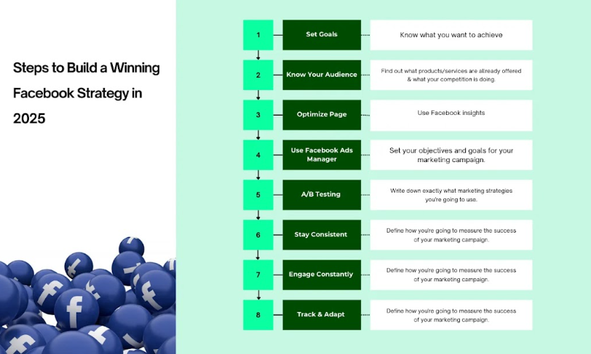

1. Define Clear Goals:
It is very important to set goals before stepping into the Facebook marketing process. You can know about your goals by asking questions like:
What are your goals?
Do you simply need to promote your brand?
How to make people interested in your products or services?
How to make third parties buy your products?
Clear objectives are important because they will define the direction of your strategy and the ability to assess the level of results.
- Specific/Measurable: Obtain the materials needed for the meeting for the new product.
- Achievable/Realistic: Accomplish this by 9 am in preparation for the meeting scheduled at 10 a.m.
- Relevant/Timely: It will enable efficient preparation for the meeting attendees to review the new product.

2. Understand Your Audience:
It helps you in the creation of good content that will, in return, attract the intended audience.
From the available online social media sites, Facebook can be used to look at demographic analysis, categories of interest, and behaviors.
Through the use of Facebook Marketing, you can easily understand who your audience is as well as what they are interested in to ensure that your delivery of information fits this demographic.

3. Optimize Your Facebook Business Page:
Your business page is basically your company’s presence on the social media site, and it is very important.
Make it clean, neat, and uncluttered.
Make sure prospective buyers do not have any issues in finding what they are looking for.
It is strongly recommended to provide informative and descriptive text, phone numbers, or email addresses, and clear CTAs.
Ensure you update your regular page to meet the needs of the readers so that the page remains interesting.

4. Leverage Facebook Ads Manager:
This is a platform that is very effective when it comes to accessing a wider market through advertising.
It can be used for creating specific ad campaigns, setting up the budget, as well as monitoring activity.
In this case, you can take advantage of Facebook targeting features, so your ads will be shown only to relevant clients.

5. Use A/B Testing:
A/B testing involves letting users see variations with the ad creatives, headlines, images, and segments to select which works best.
Therefore, with variation, you can discover what is favorable among the audience and also improve your advertisements’ performance.
The A/B testing is critical as it assists in fine-tuning the strategies and enhancing the ROI.

6. Post Consistently:
It is essential to be consistent in promoting the use of the platform in order to keep active on the Facebook site.
The best way is to create an editorial calendar to organize your posts for weekends and several weeks in advance.
Consistency ensures that the audience remains active by constantly catering to their feeds and helps in building up the credibility of the brand on the social networking site.
It might be useful to maintain a fairly equal proportion of promotional and valued information in a newsfeed.

7. Engage with Followers:
Engagement goes beyond posting content.
Whenever your posts get comments, messages, or mentions, you should try to reply to them as soon as possible.
Express your gratitude to the audience and thank them for engaging.
Interaction with the followers can assist in creating relationships, encourage followers to remain loyal to the brand, and improve the standing of the image.

8. Monitor & Adjust Strategies:
You should always be checking your performance on Facebook through the analytics tools available.
To evaluate the effectiveness of the given strategy and consider it as the major KPI in analysis, you should track the engagement rates, click-through rates as well and conversion rates.
Make sure that you are making use of this data to make some necessary amendments and changes to your campaigns as you continue your practice.

9. Stay Updated with Trends:
Facebook’s algorithm and its features are changing from time to time due to the current trends.
It is advisable to keep you posted about the recent trends to keep your strategy relevant.
Whether it is new ad formats, changes in the algorithm, or the newer forms of content that you need to be up to date with, everything will be easy to manage when you remain updated with the trends.

5. Effective Tools for Facebook Marketing
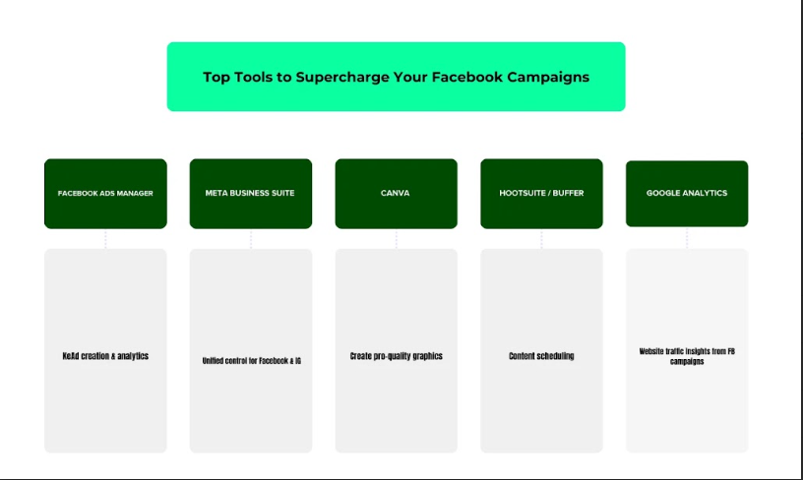

1. Facebook Ads Manager:
Facebook Ads Manager is the main tool of Facebook marketing.
It offers brands the ability to design and implement, as well as monitor, advertisement campaigns and executions effectively.
In this case, a user can define the budget, point out the audience, and choose the kind of ads they would like to have.
The potential of the platform is shown through the detailed information on your ads’ results, which allows you to make statistically based decisions for the campaign's improvement.

2. Meta Business Suite:
Meta Business Suite can be described as an integrated set of tools for the effective administration of the company’s Facebook account.
It integrates your Facebook and Instagram accounts, making it easy for you to post, reply to private messages, and get statistics for the post.
This tool is very helpful to firms that are managing multiple social media accounts and aiming to maintain a good brand image across all their accounts.

3. Canva:
Canva is one of the simplest design tools that organizations can use to enhance the appearance of their Facebook pages.
Being an online tool, Canva’s library of templates, graphic elements, and fonts is extensive, making it possible for a beginner in graphic design to create high-quality visuals.
Effective use of graphics is an important factor in attracting the attention of your target market when marketing on the Facebook page.

4. Hootsuite/Buffer:
Both Hootsuite and Buffer offer robust scheduling and automation features.
These tools enable you to be in a position to arrange your articles in advance in a proper manner.
It makes the work easier and ensures your content is posted at the right time when there are many users online interested in seeing it.

5. Google Analytics:
Essentially, this tool is not Facebook related but it is very important in analyzing the performance of the implemented Facebook marketing strategies.
Facebook users, who are also GA users, can share the traffic, conversion data, and activity on their websites. This data tells everything about your Facebook marketing and how it contributes to the overall success of your brand.

6. Facebook Marketing Tips for 2025
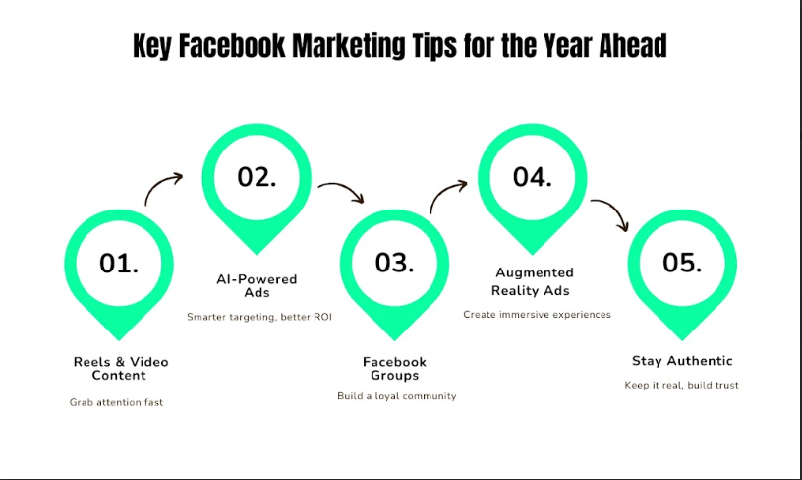

1. Prioritize Video Content and Reels for Higher Reach:
Video content remains tops in the social networks, and Facebook is not the exception.
For Facebook in 2025, focusing on the video format, such as Reels, would be effective to expand the audience.
Videos are more pleasing to the eye and passable to share as compared to text; therefore, using videos helps in attracting attention.
Some ideas for posting on the site could include funny, informative, or even behind-the-scenes videos that will help engage the audience.

2. Utilize AI-Driven Ad Optimizations:
AI has become one of the emerging capabilities that is rapidly changing how businesses undertake advertising.
Facebook uses Artificial Intelligence to identify the best parameters to use when placing the advertisement, who to advertise to, how to advertise to them, and where to advertise to them.
This way, by using AI in this case, you will be able to reach the right people who would engage with your ads and follow the call-to-action.

3. Focus on Community-Building through Facebook Groups:
Engaging customers in creating a community tends to act in favor of the interest of the brand.
Users can join a group or create a group to have a platform where they can communicate with like-minded people.
By creating special groups, there is a better connection with the audience, consumers, or potential customers, cope with feedback, and offer relevant information.
This type of approach will help enhance the impact of your brand within the community and build a sustained interaction with the readers.

4. Experiment with Augmented Reality (AR) Ads:
Augmented reality (AR) in the advertising process is now a popular trend in development.
Facebook also has utilities so that businesses can place augmented reality advertisements that are interactive to consumers.
In this regard, AR ads can help capture the users’ attention and make the ads stand out and more memorable.
To summarize, it is clear that playing with AR is a good way of differentiating the brand and reaching out to the audience with a unique experience that will be memorable.

5. Maintain Authenticity to Build Trust with Audiences:
In times when people are overwhelmed with different adverts, people are in search of genuine and real advertisements.
Therefore, you should aim to be truthful to your audience and avoid saying things that you do not believe are true.
Tell your own experiences, communicate with the audience, let your audience answer, and participate in the discussion.
Introducing authenticity in your products will help in the development of a strong brand image and customer loyalty among followers.

Conclusion
Facebook marketing for business is promising and holds more fortune for the interaction between businesses and their audiences by 2025.
Through Facebook Ads Manager, Meta Business Suite, Canva, Hootsuite/Buffer, and Google Analytics, you can achieve all your marketing objectives.
These strategies might sound quite difficult to adopt; however, with the help of Three Angle Marketing, which is a leading Facebook marketing agency in Dubai, any business can master the ever-changing landscape of Facebook marketing.
We are here to assist you in developing tailor-made marketing strategies that are suitable for your business needs and the achievement of your goals.
If you are ready to turn your Facebook marketing into the next level, here is how to go about it.
You can email us at [info@threeanglemarketing.com] for the most suitable Facebook marketing strategy depending on your enterprise’s requirements.
Do not wait any longer and start your way to success now!

